Election Mastery Assignment
Error log
Stefan S
CSE 2140 2nd Language Programming
(Election.java)
Describe the errors you’ve encountered while working on this assignment. What caused the error and how do you overcome the error?
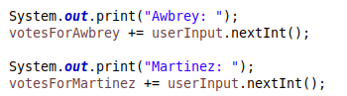
I accidentally used println instead of print for these lines, causing the user’s input to appear on the wrong line.

I used /t here instead of \t which caused the program to literally print /t at the end of the line:
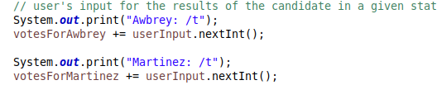
This program was fairly straightforward. The rest of my errors came from me trying to format the output.

